**SIMPLE CALCULATOR**

By:-

Ch.Nikhil

RA2111003011615

**STATEMENT:-** To Create a Simple Calculator Program using the C- Programming Language.

Algorithm of Calculator Program:

**Step 1:** Declare local variables n1, n2, res, opt. For example, where n1 and n2 take two numeric values, res will store results and opt variable defines the operator symbols.

**Step 2:** Print the Choice (Addition, Subtraction, multiplication, division,etc.)

**Step 3:** Enter the Choice

**Step 4:** Takes two numbers, n1 and n2

**Step 5:** Switch case jump to an operator selected by the user

**Step 6:** Store result into res variable.

**Step 7:** Display the operation result

**Step 8:** Exit from the program.

The different ways to write a Calculator Program in the C language.

1. Calculator Program in C using the switch statement
2. Calculator Program in C using if else if statement
3. Calculator Program in C using do-while loop and switch statement
4. Calculator Program in C using function and switch statement

In this Mini project that we do, we write the Calculator Program Using the do-while loop and Switch Statement. i.e the 3rd way.

**Program:- Calculator program using do-while loop and switch case statement in C**

#include <stdio.h>

#include <math.h> #include <stdlib.h>

int main()

{

// declaration of local variable op; int op, n1, n2; float res; char ch;

do

{

// displays the multiple operations of the C Calculator printf (" Select an operation to perform the calculation in C Calculator: "); printf (" \n 1 Addition \t \t 2 Subtraction \n 3 Multiplication \t 4 Division \n 5

Square \t \t 6 Square Root \n 7 Exit \n \n Please, Make a choice ");

scanf ("%d", &op); // accepts a numeric input to choose the operation

// use switch statement to call an operation switch (op)

{

case 1:

// Add two numbers printf (" You chose: Addition"); printf ("\n Enter First Number: "); scanf (" %d", &n1); printf (" Enter Second Number: "); scanf (" %d", &n2); res = n1 + n2; // Add two numbers printf (" Addition of two numbers is: %.2f", res); break; // break the function

case 2:

// Subtract two numbers printf (" You chose: Subtraction"); printf ("\n Enter First Number: "); scanf (" %d", &n1);

printf (" Enter Second Number: "); scanf (" %d", &n2); res = n1 - n2; // subtract two numbers printf (" Subtraction of two numbers is: %.2f", res); break; // break the function

case 3:

// Multiplication of the numbers printf (" You chose: Multiplication"); printf ("\n Enter First Number: "); scanf (" %d", &n1); printf (" Enter Second Number: "); scanf (" %d", &n2); res = n1 * n2; // multiply two numbers printf (" Multiplication of two numbers is: %.2f", res); break; // break the function

case 4:

// Division of the numbers printf (" You chose: Division"); printf ("\n Enter First Number: "); scanf (" %d", &n1); printf (" Enter Second Number: "); scanf (" %d", &n2); if (n2 == 0)

{ printf (" \n Divisor cannot be zero. Please enter another value "); scanf ("%d", &n2);

}

res = n1 / n2; // divide two numbers printf (" Division of two numbers is: %.2f", res); break; // break the function

case 5:

// getting square of a number printf (" You chose: Square"); printf ("\n Enter First Number: "); scanf (" %d", &n1);

res = n1 * n1; // get square of a number printf (" Square of %d number is: %.2f", n1, res); break; // break the function

case 6:

// getting the square root of the number printf (" You chose: Square Root"); printf ("\n Enter First Number: "); scanf (" %d", &n1);

res = sqrt(n1); // use sqrt() function to find the Square Root

printf (" Square Root of %d numbers is: %.2f", n1, res); break; // break the function

case 7:

printf (" You chose: Exit"); exit(0); break; // break the function

default: printf(" Something is wrong!! "); break;

} printf (" \n \n ********************************************** \n ");

} while (op != 7);

return 0;

}

**Output:-**

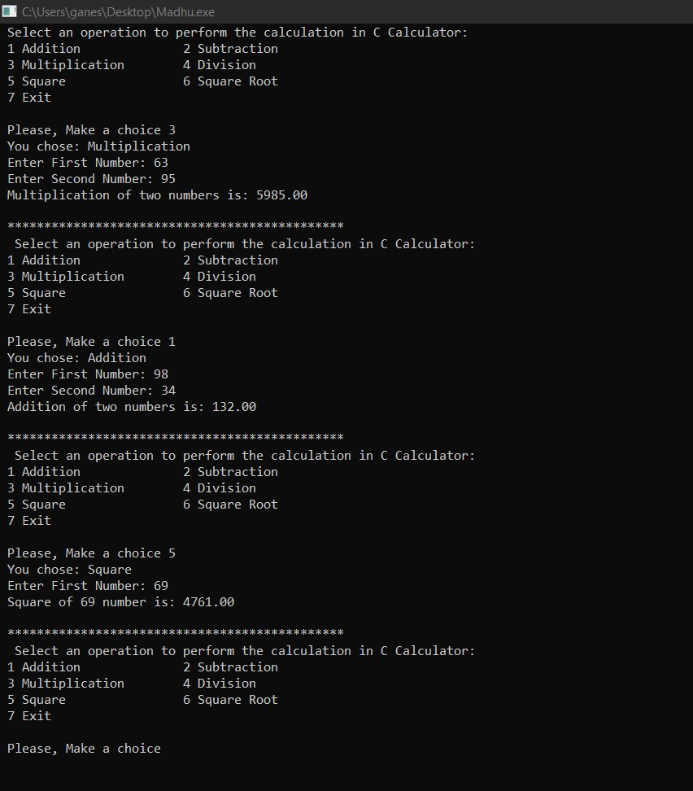

**Result:-** Hence we created a Simple Calculator Program using the do-while loop and switch case statement in C.